TITLE PAGE
Authors: Tamsyn Murphy, Claremont, Cape Town.
Seth Luther, Claremont, Cape Town.
Executive Summery
The main purpose of this project was to allow each of the users the opportunatity to code(program) there own initials into Visual Studio using C++, after each user had a time to create there own initials as a team sit and work together by adding the initials together, as shown in the figure 1 below.
INSERT IMAGE OF COMPLETE ANIMAL

The project diary contains record of the dates we met and when we started to code the work our own work and our combined work. Top-level design shows the overview of the created program. The User Manual is very important as it will guide the user on how to run and use the functions of the program.
Then lastly there is the conclusion where each group member states what they learnt, what they would do differently next time, if any improvement had been made if they were given more time and how the project can be improved on for next year.

Introduction
This documentation will guide you threw using the keys and it will illustrate the “Chicken” we created, you will receive a top down view of the program. This documentation will consist of.
- Project Diary.
- Top-level Design of the program.
- Graphical user manual.
- Top-Level scene Graph.
- Code List of Top-Level scene Graph.
- Code List for Scene Graph for Student.

1 Project Diary
The following table below explains in detail when we met and what happened during the course of the project.

February 2014
13 February 2014 – Received computer graphics project.
14 February 2014 – Chose group mates (Seth and Tamsyn)
20 February 2014 – Started studying examples
25 February 2014 – Started brainstorming on what animal to do
March 2014
06 March 2014 – Learnt about polygons and started making polygons
14 March 2014 – Allocated letters to make to each group mate
20 March 2014 – Started making letters
28 March 2014 – Continued making letters
April 2014
03 April 2014 – Group discussion about progress
11 April 2014 – Moved on to making remaining letters
17 April 2014 – Submission of letters to one main file
25 April 2014 – Submitting of letters to be put in one main file
29 April 2014 – Animal started being made with articulation
May 2014
02 May 2014 – Group looked at animal together
08 May 2014 – Final code changes and modified the animal

Figure 1 - Project Diary Table

2 Top – level design of program

Our main DrawBird () is made up of 2 main functions which are DrawHead () and DrawBodyTailFoot ().
Our void DrawT(float foot_angle) takes a parameter that rotates one of the polygons that draws the T.

The DrawHeadNeck () calls DrawHead () which will make up the head and the neck from the following letters DrawQ (), DrawB (), DrawA () and DrawN ().
DrawBodyTailFoot () calls on the DrawFoot () which will draw the foot of the animal with the letter DrawT (). DrawBodyTail () is also called in DrawBodyTailFoot () which will draw the body and the tail of the animal using the following letters, DrawO (), DrawM (), DrawC () and DrawB ().
Global Variables:
Pressing W on the keyboard will update the following global variable to rotate the wing.
//Wing
case 'w': wing_angle+=10; break;
case 'W': wing_angle-=10; break;

Pressing L on the keyboard will update the following global variable to move forward and backward on one axis.
//Leg
case 'l': leg_angle+=10; break;
case 'L': leg_angle-=10; break;

Pressing F on the keyboard will update the following global variable to rotate the foot.
//Foot
case 'f': foot_angle+=10; break;
case 'F': foot_angle-=10; break;

By pressing L and F at the same time executes double articulation.
The diagram below shows the overview design of the program and how all functions communicate.

Figure 2 - Overview design of program

3 Graphical user manual
Brief summary:
The entire Animal which is a Chick in this case has the ability to move its wing in a single articulation which uses a rotation function. The double articulation allows the leg and foot to move in a walking like manner. The following Keyboard keys execute the functions mentioned above.

To view the project, you must open first the folder named Computer Graphics Project as shown below:
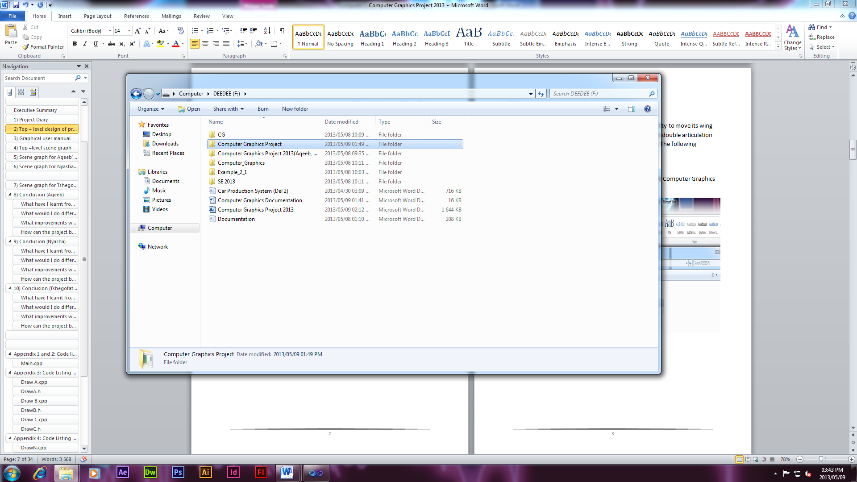
Figure 3 - User Manual 1
When you double click the Computer Graphics Project folder, it will then open up the project and the following will appear once clicked opened.

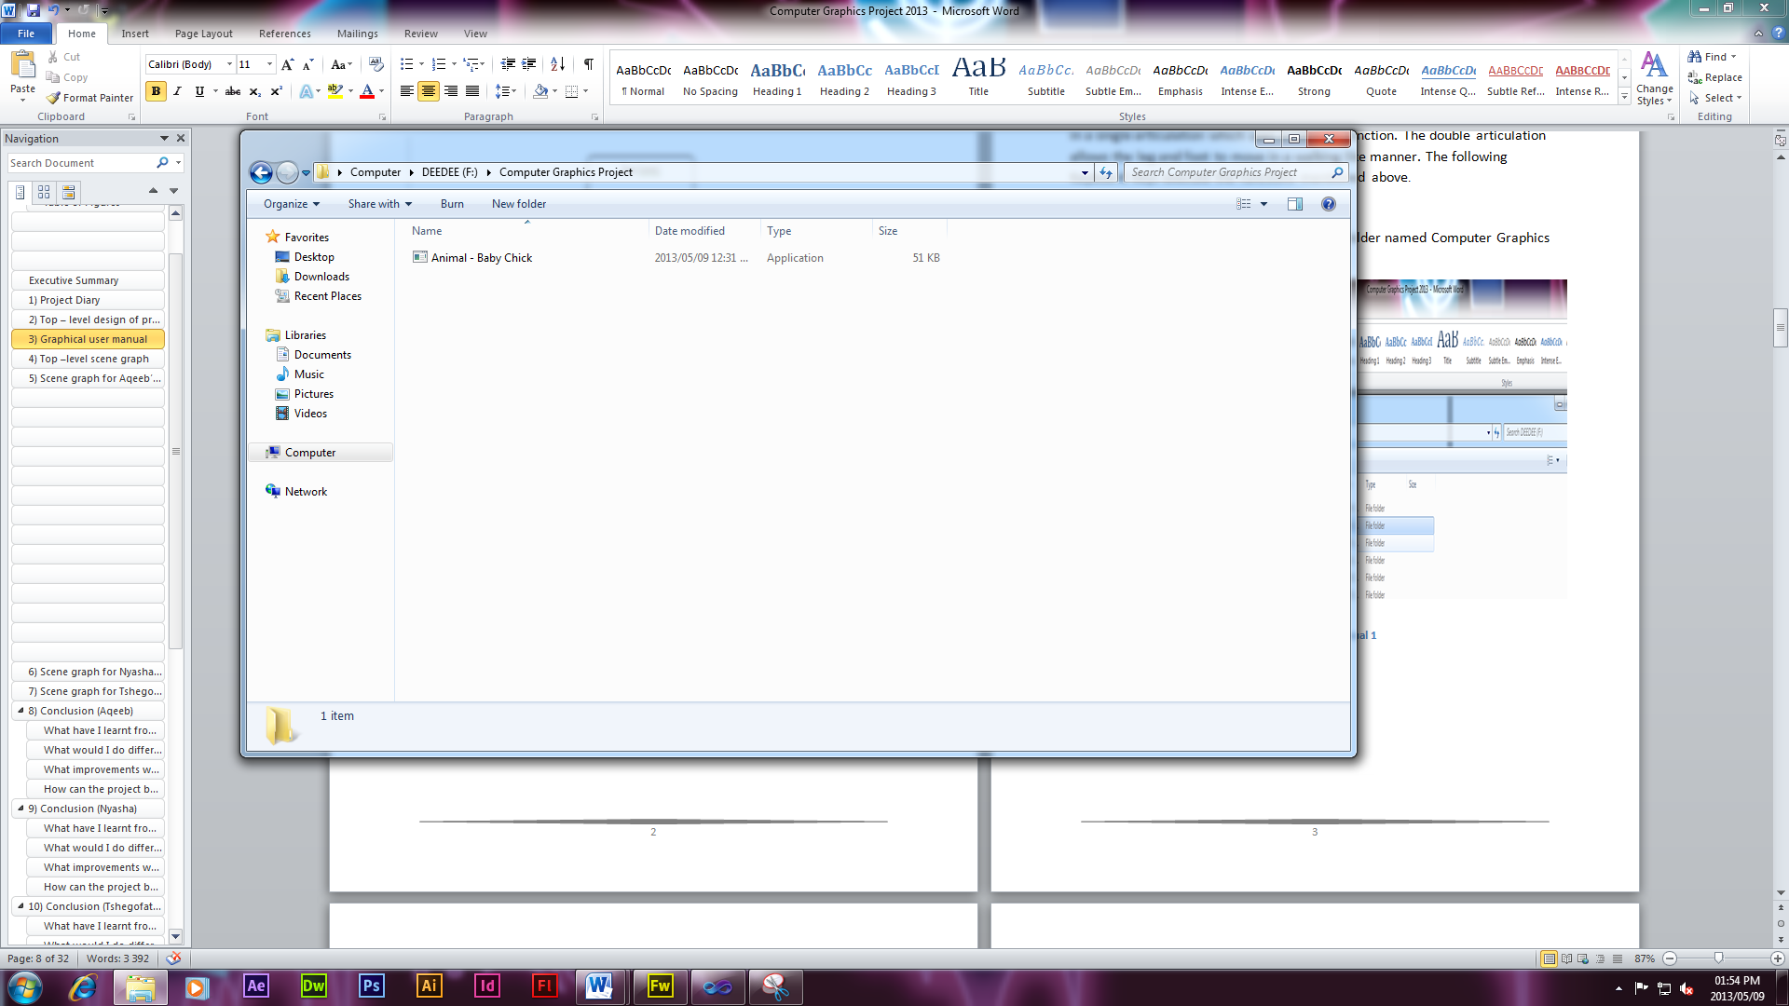

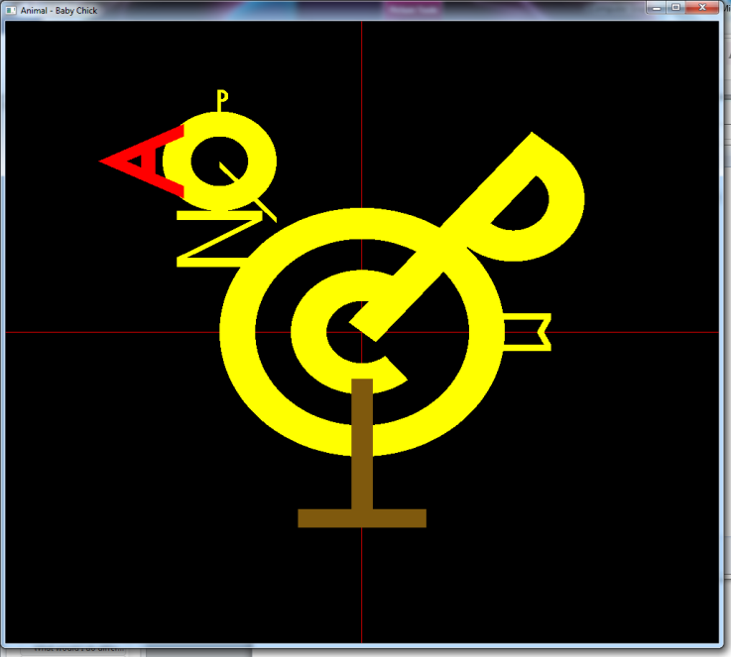

Figure 4 - User Manual 2
Pressing W on the keyboard will rotate the wing executing single articulation.
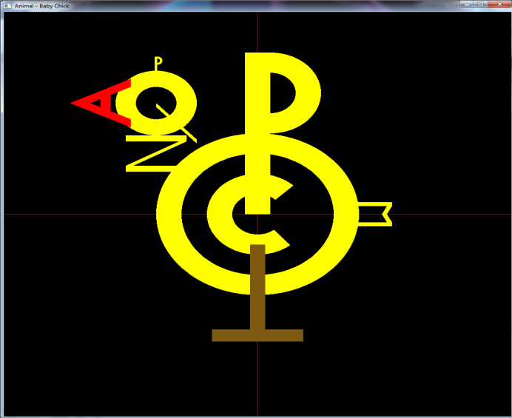
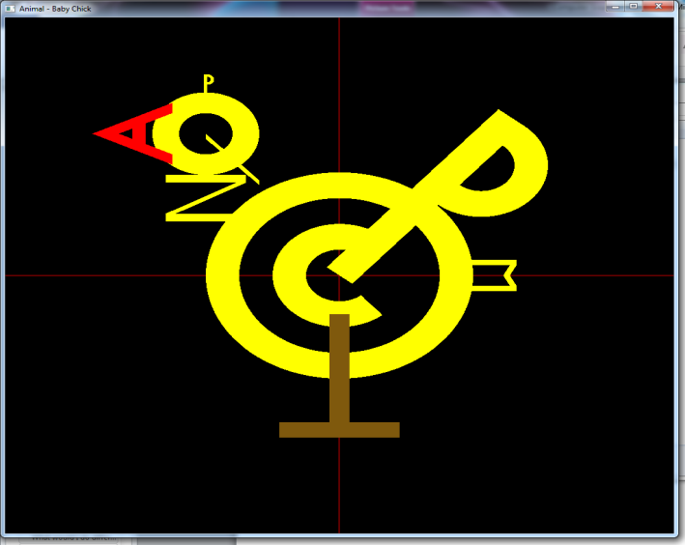

Figure 5 – Single Articulation

Pressing L on the Keyboard will rotate the Leg and Pressing F the same time will execute double articulation.
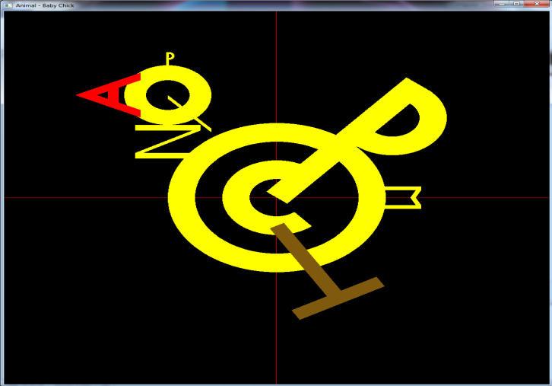
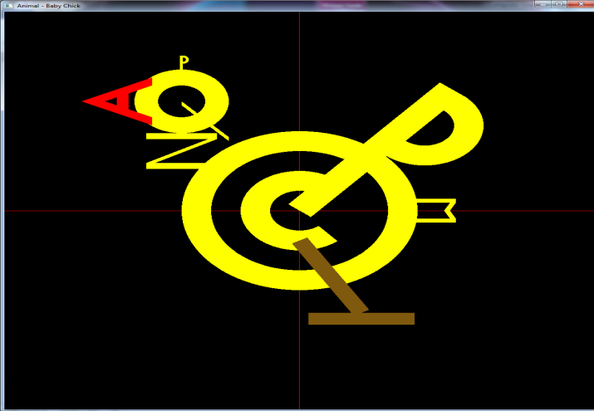

Figure 6 – Double Articulation

In Summary this is how our program runs executing single and double articulation as shown above.

3) Graphical user manual
Brief summary:
The entire Animal which is a Chick in this case has the ability to move its wing in a single articulation which uses a rotation function. The double articulation allows the leg and foot to move in a walking like manner. The following Keyboard keys execute the functions mentioned above.

To view the project, you must open first the folder named Computer Graphics Project as shown below:
Figure 7 - User Manual 1
When you double click the Computer Graphics Project folder, it will then open up the project and the following will appear once clicked opened.

Figure 8 - User Manual 2
Pressing W on the keyboard will rotate the wing executing single articulation.

Figure 9 – Single Articulation

Pressing L on the Keyboard will rotate the Leg and Pressing F the same time will execute double articulation.

Figure 10 – Double Articulation

In Summary this is how our program runs executing single and double articulation as shown above.

4) Top –level scene graph
The Diagram below displays the Top – level scene graph of our program.

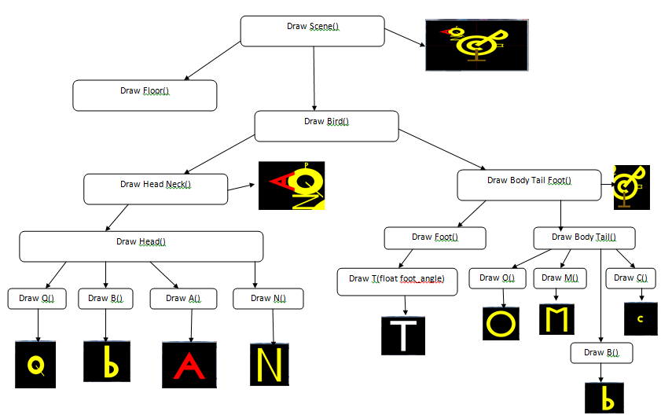
Figure 11 - Top level scene

5 Scene graph for Seth’s initials

The following letters U, S and L were created by Seth Luther.

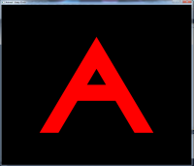
DrawU()

DrawCube()
DrawCurve()
DrawCube()



Figure 12 – DrawU()


DrawS()

/
DrawCurve()
DrawCurve()
//

Figure 13 - DrawS()

DrawL()

/
DrawCube()
DrawCube()
/

Figure 14 - DrawL()

- DrawU() was constructed by making 2 Cubes and 1 Curve. Each Cube and Curve was made with its own co-ordinates (refer to DrawU().cpp under Appendix 3).
- DrawS() was constructed by 2 Curves (refer to DrawS().cpp under Appendix 3).
- DrawL() was constructed by 2 Cubes (See DrawL().cpp under Appendix 3).

10) Conclusion (Tshegofatso Mosidi)

What have I learnt from the project?
That working with opengl and glut is easier than working with normal programming languages because the event loops makes life easier.

What would I do differently next time?
Try a project that works in 3D.

What improvements would I add if I had twice the time available to me?
I would have added a mouse call back function that would make it rotate the animal and make it viewable from different angles.

How can the project be improved for next year?
Put a limited range of movement for the limbs.

